HEALTHCARE SERVICE AND PATIENT DATA
VISUALIZATION ANALYTICS SYSTEM
DSA06 / Data Handling and Visualization — Industry-Oriented Assignment Report
PARTICULAR | DETAILS
Department | Computer Science and Engineering
Program | BE
Course Code & Course Name | DSA06 / DATA HANDLING AND VISUALIZATION
Assignment Title | Healthcare Service and Patient Data Visualization Analytics System
Dataset Used | Synthetically generated, anonymized healthcare service dataset (10,000 records) — see Section 3
Implementation Language | Python 3.12
Key Libraries | pandas, NumPy, Matplotlib, Seaborn, scikit-learn (PCA, t-SNE), SciPy
Maximum Marks | 100

1. Problem Understanding and Formulation

1.1 Understanding of the Healthcare Data Problem
Healthcare organizations collect a large amount of information every day, including patient visits, diagnostic tests, treatments, waiting times, service charges, and feedback. Although this information can be stored safely in databases and spreadsheets, it is not always easy for administrators and analysts to understand what the data is saying. When thousands of records are viewed only as rows and columns, important patterns and comparisons can easily be missed. This project therefore focuses on turning the raw healthcare data into clear visual forms that can help hospital administrators and analysts understand the information more quickly and make better evidence-based decisions.
The situation becomes more interesting because healthcare data contains different types of variables. For example, department, gender, and service type are categorical, while visits and diagnostic tests are counts. Waiting time, treatment cost, length of stay, and satisfaction score are continuous numerical values. Since each type of data behaves differently, the choice of chart is important. The aim is not simply to create many charts, but to select a visualization that makes each type of information easy to understand.

1.2 Dataset Characteristics
For this prototype, a synthetically generated and fully anonymized healthcare dataset containing 10,000 records and 12 variables was used. The data was designed to resemble the kind of patterns normally seen in hospital service records, including skewed waiting times and treatment costs and meaningful relationships between variables. This makes the analysis more useful than working with completely random values. The dataset contains:
- Identifiers: an anonymized Record_ID (no real patient names or identifiers).
- Categorical variables: Gender, Department, Service_Type, Service_Category.
- Discrete numerical variables: Number_of_Visits, Number_of_Diagnostic_Tests.
- Continuous numerical variables: Age, Waiting_Time_Minutes, Length_of_Stay_Days, Treatment_Cost_USD, Patient_Satisfaction_Score.

1.3 Requirements
Functionally, the system loads and inspects the dataset, classifies each variable by type, applies appropriate visual aesthetics (position, colour, size, shape), and generates at least one visualization for each analytical category required by the assignment: amounts, distributions, proportions, relationships, correlation, and dimensionality-reduced multivariate patterns. It computes a correlation matrix and applies both PCA (mandatory) and t-SNE (comparison technique). Every chart includes a meaningful title, labelled axes, and a legend where relevant.

1.4 Assumptions
- The dataset is anonymized — no real patient names, contact details, or exact addresses are used or required.
- Missing or invalid values occur in real-world healthcare data and are handled explicitly (median imputation for numeric fields) rather than assumed absent.
- Relationships explored (e.g., waiting time vs. satisfaction, tests vs. cost) are treated as associations, not proven causal effects, since the data is observational.
- Variable classifications are made explicitly and documented, since this choice determines which visualizations are valid.

1.5 Constraints
The implementation uses Python 3.x with standard data-handling and visualization libraries (pandas, Matplotlib, Seaborn, scikit-learn), keeps patient-identifying information out of every output, documents the dataset source, and remains strictly scoped to CO1–CO3. It is a visualization and analytics prototype only — not a predictive-modelling or diagnostic system. Performance constraints require the system to remain usable and reproducible as dataset size grows from 1,000 to 10,000 records, with key steps timed and compared (Section 7).

2. Problem Statement
Develop a Python-based Healthcare Service and Patient Data Visualization Analytics System that loads an anonymized healthcare dataset, correctly identifies numerical and categorical variables, applies appropriate visual aesthetics and scales, and generates amount, distribution, proportion, relationship, and correlation visualizations. The system must additionally apply PCA and a comparison dimensionality-reduction technique (t-SNE) to multivariate patient data, compare alternative visualization/reduction approaches, and produce evidence-based analytical conclusions restricted strictly to CO1, CO2, and CO3.

3. Dataset Source and Justification
A synthetically generated dataset (10,000 records) was used in place of a downloaded third-party dataset. This was a deliberate design decision, not a shortcut: it guarantees the data is fully anonymized by construction (no risk of residual identifiers from a real-world source), it allows the dataset size to be scaled exactly to the 1,000 / 5,000 / 10,000-record benchmarks required in Section 7, and it allows realistic relationships (e.g., cost driven by diagnostic tests and length of stay; satisfaction reduced by long waiting times) to be embedded with known ground truth, which strengthens the validity of the interpretation exercise. The generation logic (variable ranges, category proportions, and the built-in relationships) is fully documented in the accompanying generate_data.py script (Appendix A) so the process is transparent and reproducible with a fixed random seed (42).
Variable | Type | Description
Record_ID | Identifier (anonymized) | Synthetic patient/record code, e.g. PT-100001
Age | Numerical, continuous | Patient age in years
Gender | Categorical, nominal | Male / Female / Other
Department | Categorical, nominal | 8 hospital departments (Cardiology, Oncology, etc.)
Service_Type | Categorical, nominal | Consultation, Diagnostic, Surgery, Therapy, Follow-up
Service_Category | Categorical, nominal | Outpatient, Inpatient, Emergency Care, Day Care
Number_of_Visits | Numerical, discrete | Count of visits associated with the record
Waiting_Time_Minutes | Numerical, continuous | Time waited before service
Number_of_Diagnostic_Tests | Numerical, discrete | Count of diagnostic tests performed
Length_of_Stay_Days | Numerical, continuous | Duration of hospital stay in days
Treatment_Cost_USD | Numerical, continuous | Total billed treatment cost
Patient_Satisfaction_Score | Numerical, continuous (1–10) | Self-reported satisfaction rating

5. Solution, Design and Methodology

5.1 Data Handling and Visualization Fundamentals (CO1)
The dataset was first checked using df.info(), df.describe(), and df.isna().sum() to understand its structure and identify missing values. A small number of missing values were found in Patient_Satisfaction_Score and Number_of_Diagnostic_Tests. These values were handled using median imputation. This approach was chosen because it is less affected by the right-skew present in these variables.

Visual mapping and justification
Variable | Aesthetic Used | Justification
Waiting time, cost, stay, age | Position (axis) | Continuous values need precise comparison; position is the most accurately perceived visual channel.
Department, Gender, Service Type | Colour | Unordered categories are best distinguished by hue for quick grouping/legend lookup.
Number of visits / tests | Size | Used as a secondary numeric channel in bubble charts (weaker but effective for a 3rd dimension).
Service Category | Colour + facet | Few categories with clear meaning; also used to facet/group boxplots and violins.

5.2 Amount Visualization (CO2)
Three techniques were implemented: a bar plot, a grouped bar chart, and a heatmap.
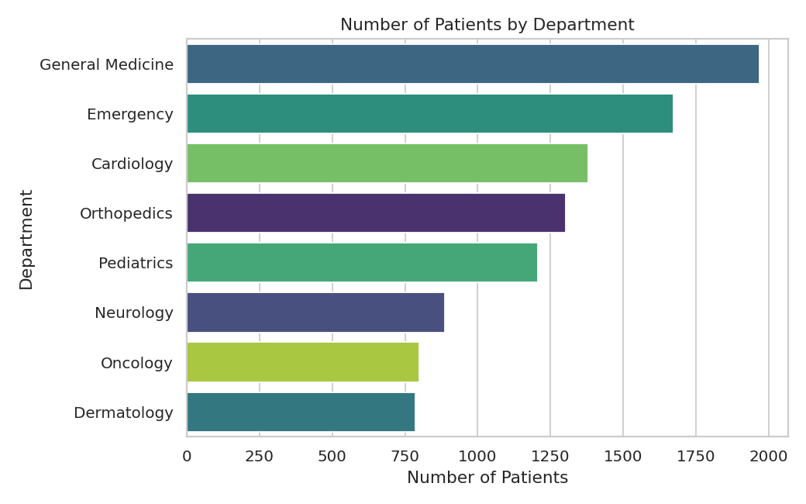
Figure 1. Number of patients by department (Bar Plot).
General Medicine has the highest patient count in this dataset, followed closely by Emergency and Cardiology — useful for administrators allocating staff and beds.
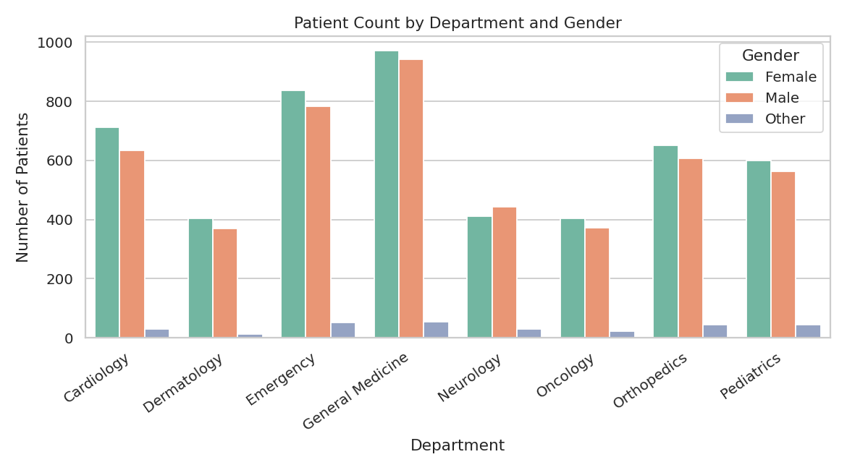
Figure 2. Patient count by department and gender (Grouped Bar Chart).
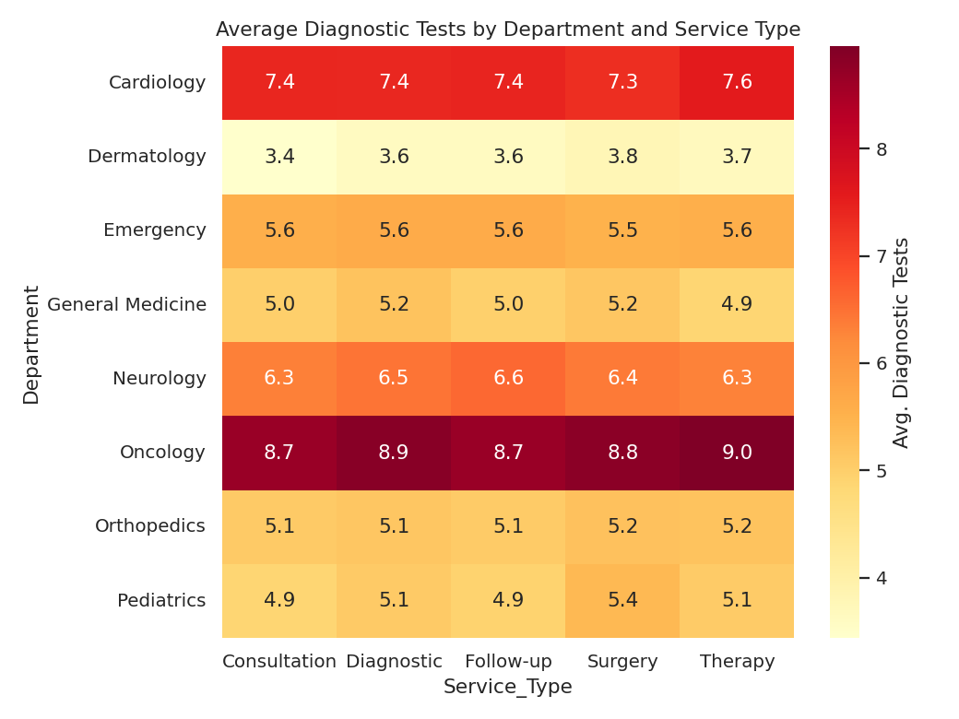
Figure 3. Average diagnostic tests by department and service type (Heatmap).
Comparison: the bar plot is clearest for a single-variable amount comparison (department counts) since bar length is the most accurately judged channel. The heatmap is superior once a second categorical dimension (service type) is introduced, since a grouped/stacked bar with 8 × 5 = 40 combinations would be unreadable, whereas the heatmap's colour-coded grid scales cleanly. The heatmap is therefore the justified choice for the two-way amount comparison, while the simple bar plot remains best for the single-variable case.

5.3 Distribution Analysis (CO2)
Four techniques were implemented: histogram, density plot, boxplot, violin plot — plus ECDF and Q–Q plot for deeper inspection.
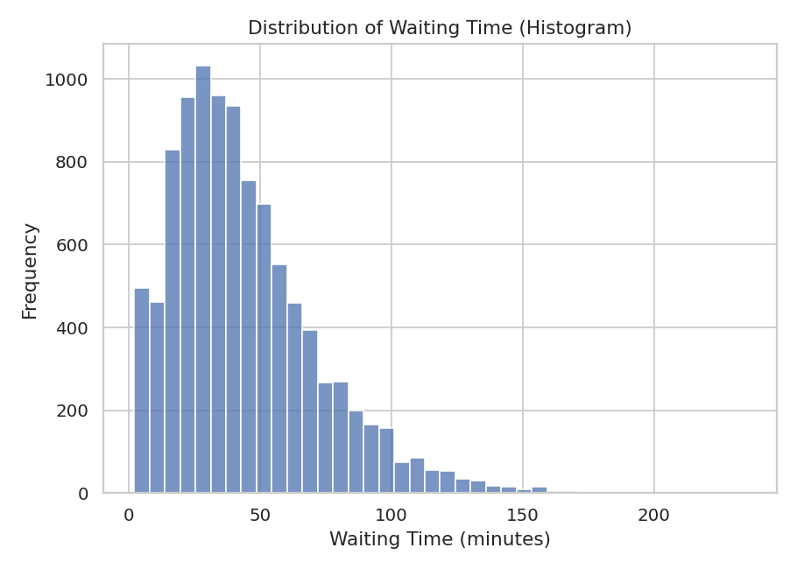
Figure 4. Waiting time — Histogram.
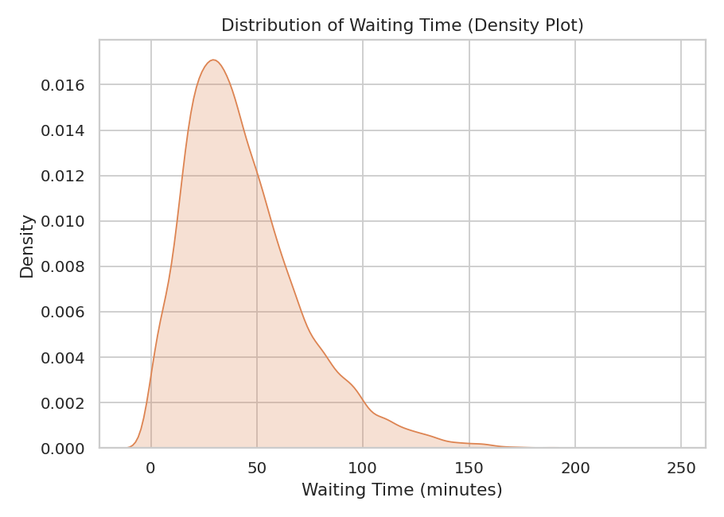
Figure 5. Waiting time — Density Plot.
Waiting time shows a skewness of 1.21 (right-skewed) — the density plot makes this long right tail immediately visible, while the histogram's bin-count view better communicates the exact shape near the peak. IQR-based outlier detection flags 291 records (~2.9%) as unusually long waits.
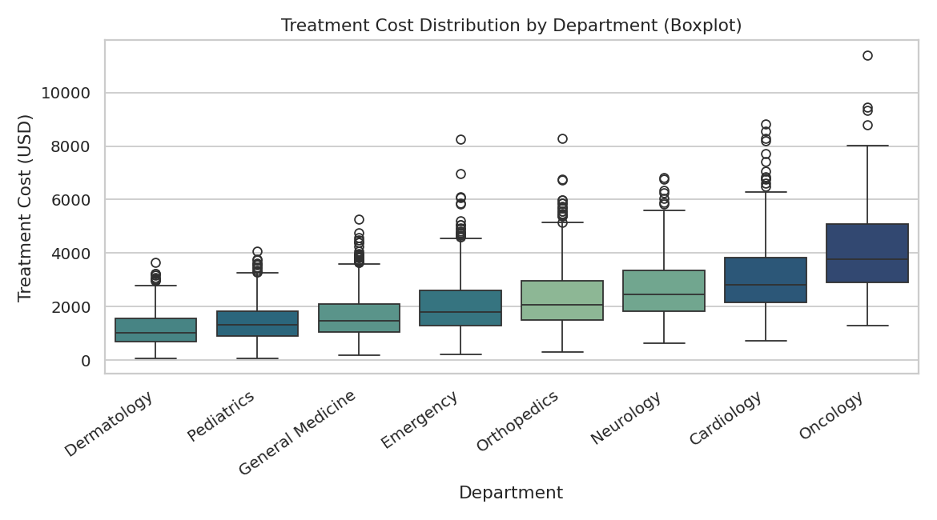
Figure 6. Treatment cost by department — Boxplot.
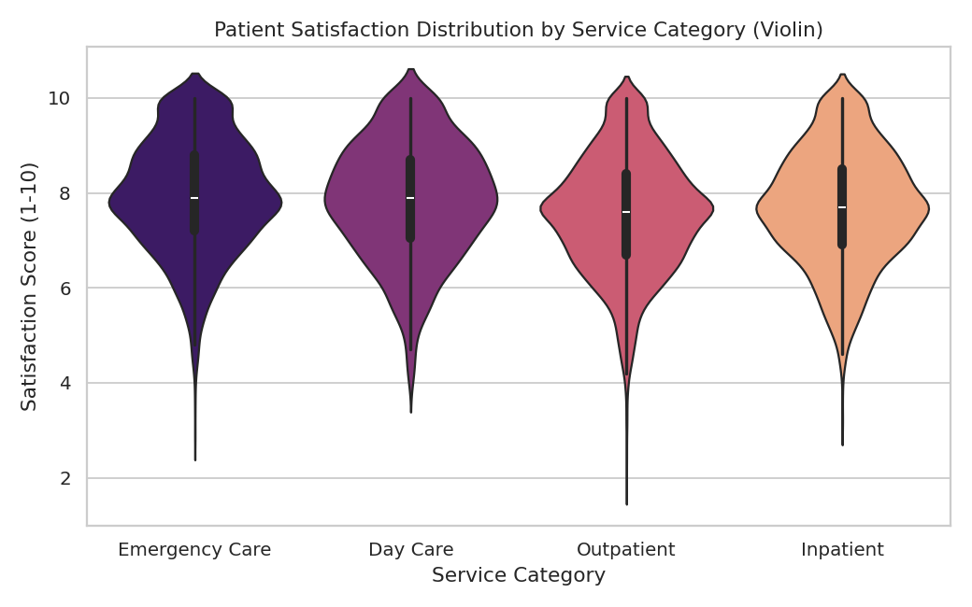
Figure 7. Satisfaction score by service category — Violin Plot.
Treatment cost has a skewness of 1.22 and varies substantially by department (visible from median position and box height in Figure 6). The violin plot for satisfaction (Figure 7) reveals the internal shape of each service category's rating distribution — information a boxplot alone would compress into five summary points.
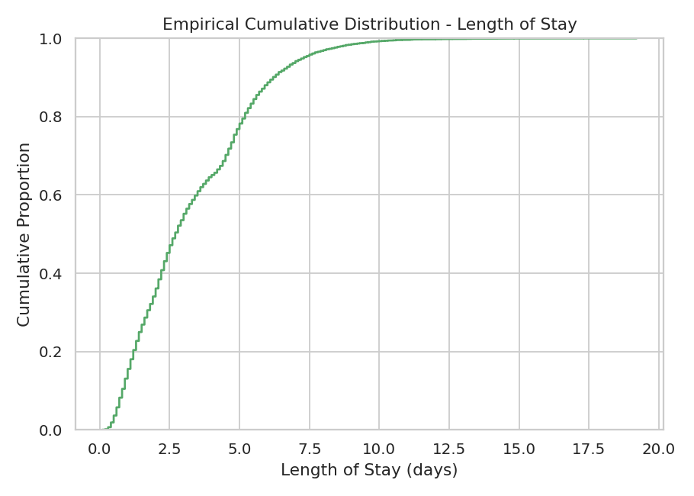
Figure 8. Length of stay — ECDF.
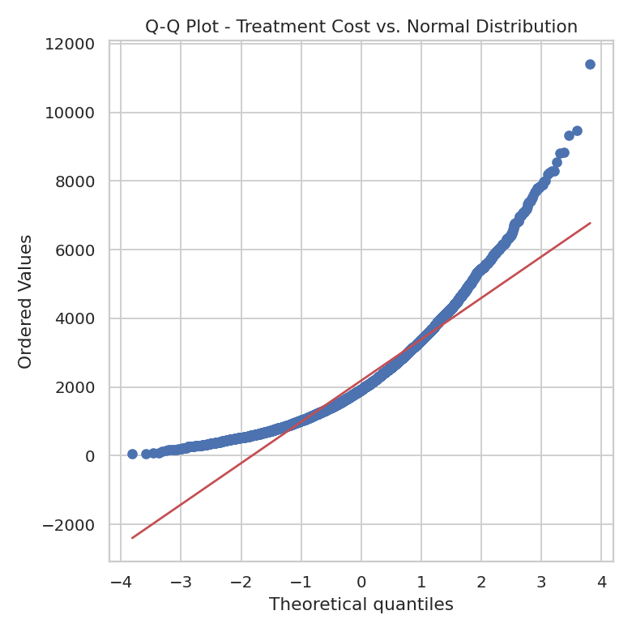
Figure 9. Treatment cost — Q–Q Plot against Normal distribution.
The Q–Q plot confirms treatment cost departs from normality in the upper tail (points curve above the reference line), consistent with its positive skew (1.22) — this justifies using median/IQR-based summaries rather than mean/standard-deviation for this variable in later reporting.
Comparison: histogram vs. density — the density plot communicates overall shape and skew faster; the histogram preserves exact frequency counts. Boxplot vs. violin — boxplots scale better across many groups (8 departments, Figure 6), while violins are preferable for a small number of groups where internal shape (e.g., bimodality) matters, as with satisfaction (4 categories, Figure 7).

5.4 Proportion Visualization (CO2)
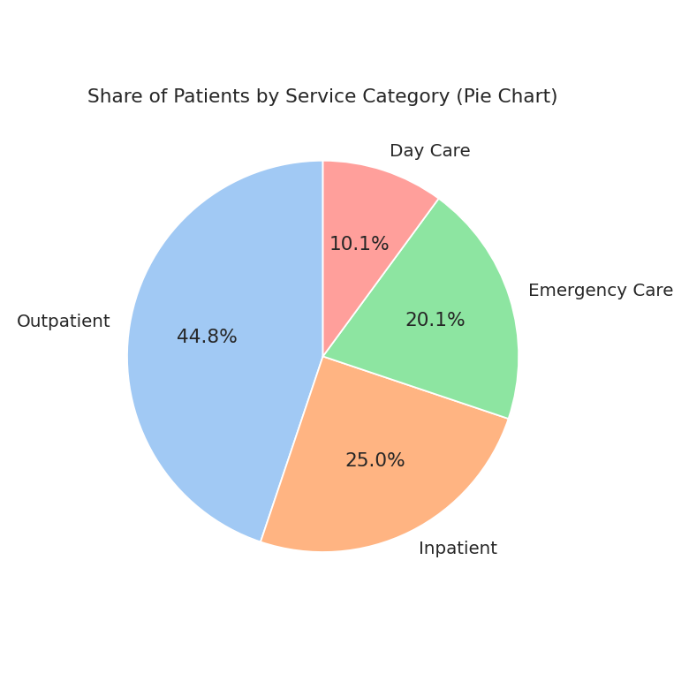
Figure 10. Share of patients by service category — Pie Chart.
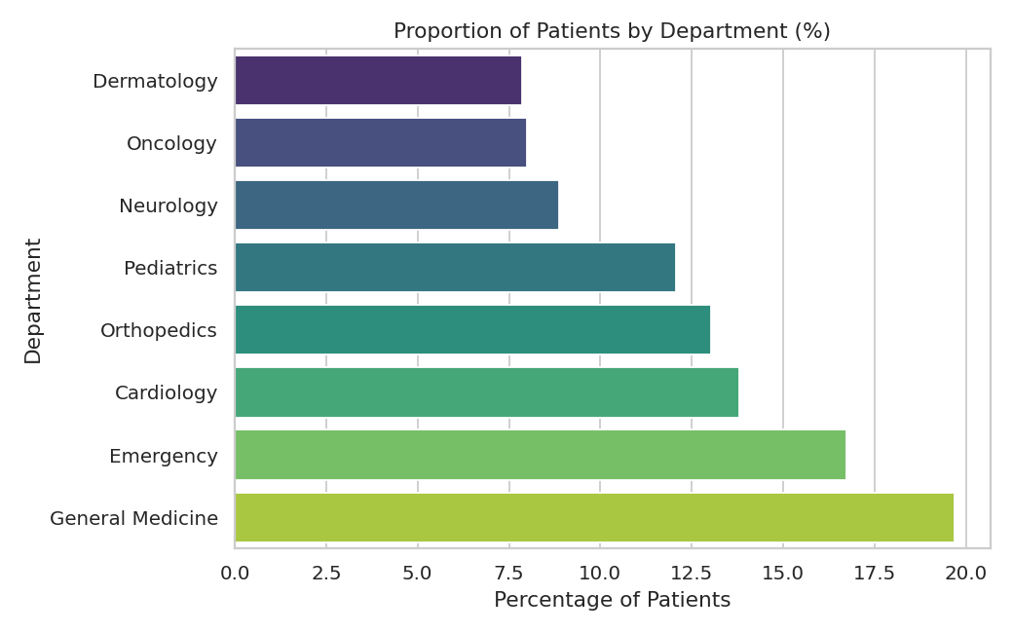
Figure 11. Proportion of patients by department (%) — Bar Chart.
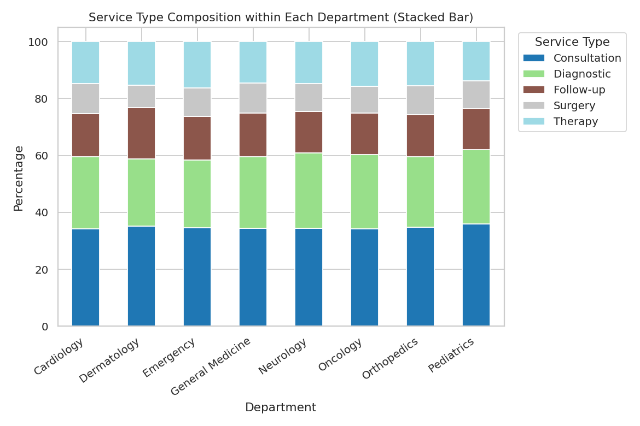
Figure 12. Service-type composition within each department — Stacked Bar Chart.
With only 4 categories, the pie chart (Figure 10) communicates service-category share clearly. However, with 8 departments of comparable size (largest = General Medicine at 19.7%), the bar chart (Figure 11) gives a more accurate ranked comparison than a pie chart would, since angle judgments degrade once slice count grows and sizes become similar. The stacked bar (Figure 12) is justified over a treemap here because the sub-category count (5 service types) is small enough that stacked segments remain readable, and it preserves an easy per-department total comparison that a treemap's area-based layout does not.

5.5 Relationship and Association Analysis (CO3)
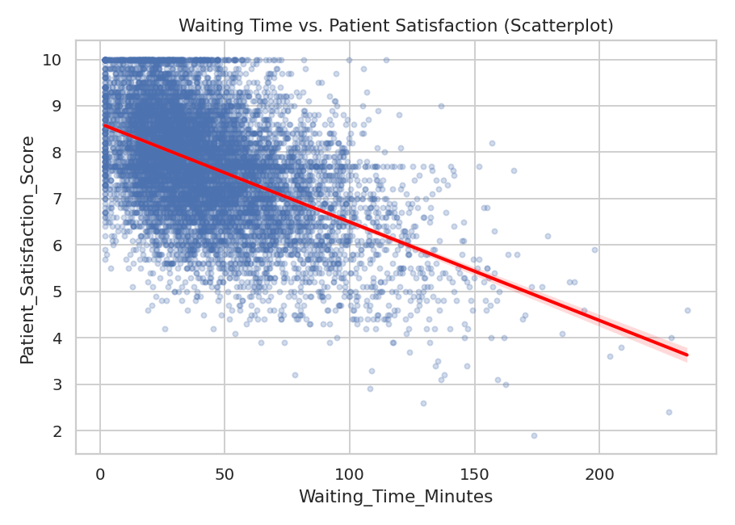
Figure 13. Waiting time vs. patient satisfaction — Scatterplot with trend line.
Correlation = -0.49 — a moderate negative association. Longer waiting times are associated with lower satisfaction scores, visible as a clear downward trend.
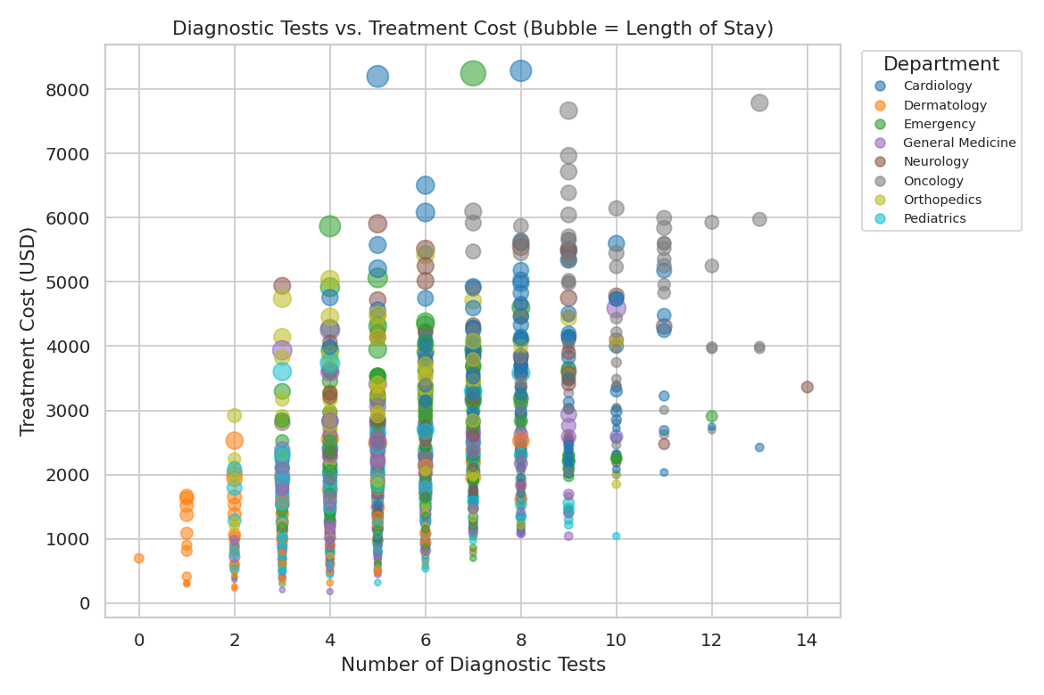
Figure 14. Diagnostic tests vs. treatment cost, bubble size = length of stay, coloured by department — Bubble Chart.
Correlation (tests vs. cost) = 0.51 — a moderate positive association. The bubble chart additionally shows that the largest bubbles (longest stays) cluster toward the upper-right, i.e., patients with more tests and longer stays also tend to incur the highest costs — a pattern a plain 2-D scatterplot would not reveal.
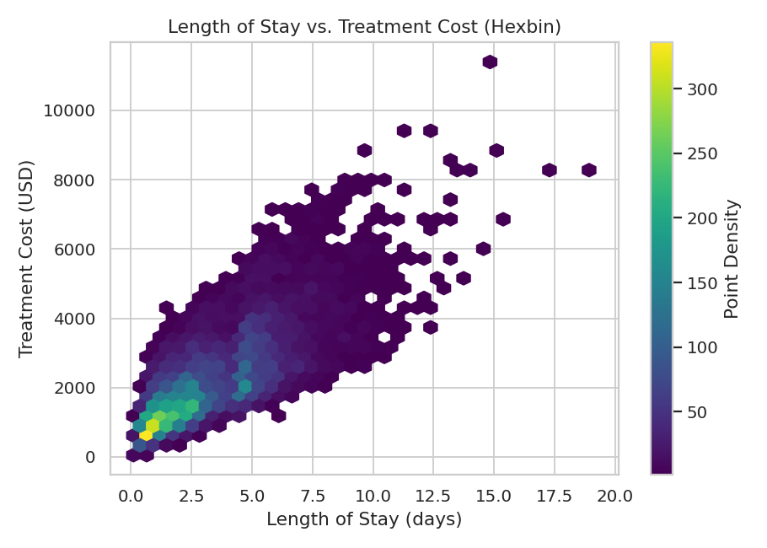
Figure 15. Length of stay vs. treatment cost — Hexbin Plot (dense data).
Correlation (stay vs. cost) = 0.75 — a strong positive association, the strongest relationship in the dataset. With 10,000 points, a plain scatterplot would overplot heavily; the hexbin plot instead uses colour intensity to show density, making the concentration of typical (short-stay, low-cost) cases clearly distinguishable from the sparser long-stay, high-cost tail.

5.6 Correlation Analysis (CO3)
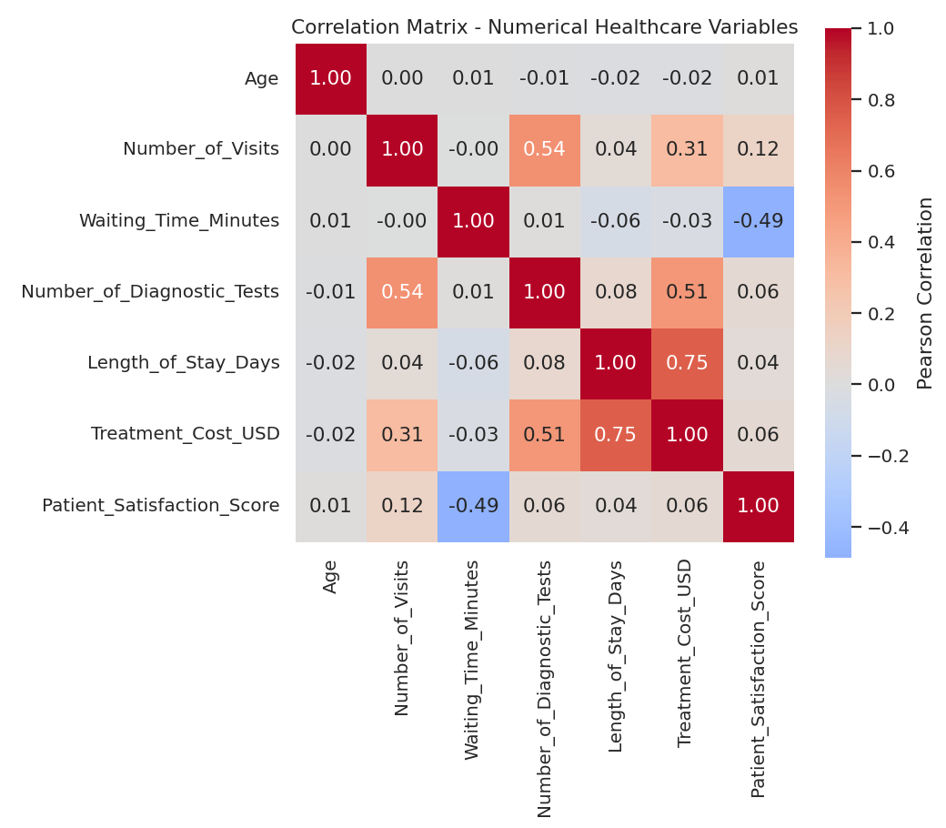
Figure 16. Correlation matrix of numerical healthcare variables — Heatmap.
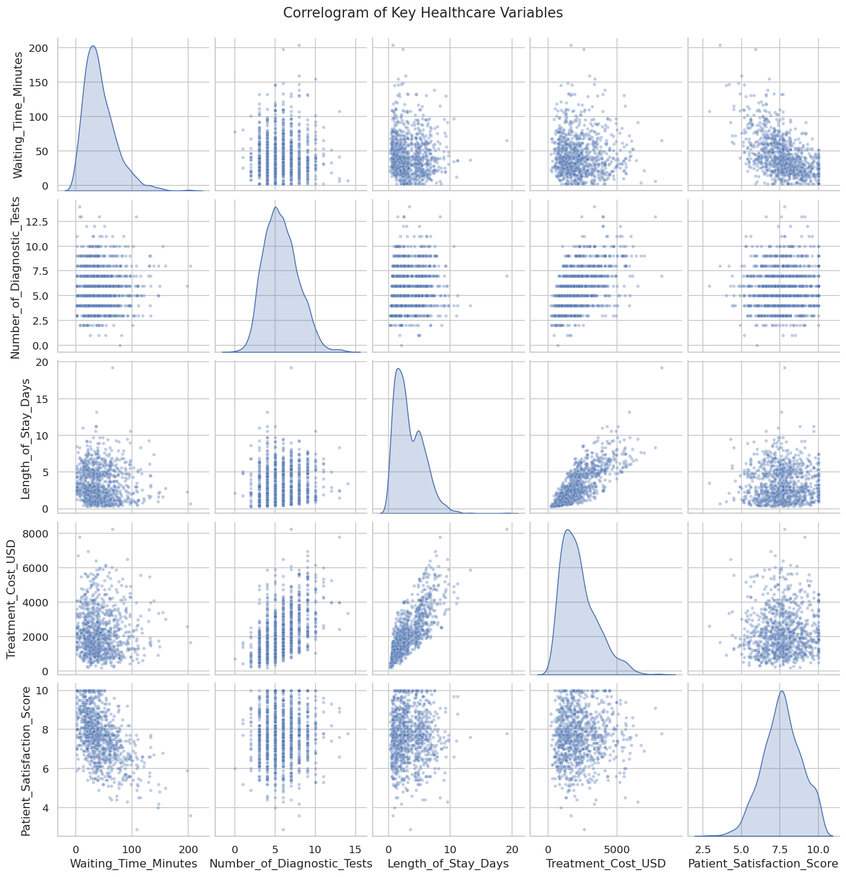
Figure 17. Correlogram of key healthcare variables (pairwise scatter + density).
Strongest positive correlation: Length of Stay vs. Treatment Cost (r = 0.75). Strongest negative correlation: Waiting Time vs. Satisfaction (r = -0.49). Number of Visits vs. Treatment Cost is weaker (r = 0.31), suggesting that how intensively a patient is treated per visit (tests, stay) matters more for cost than simply how many times they visit. Age shows negligible correlation with every other numerical variable in this dataset, indicating cost and satisfaction patterns here are driven by care intensity and service factors rather than patient age.

5.7 Dimensionality Reduction — PCA and t-SNE (CO3)
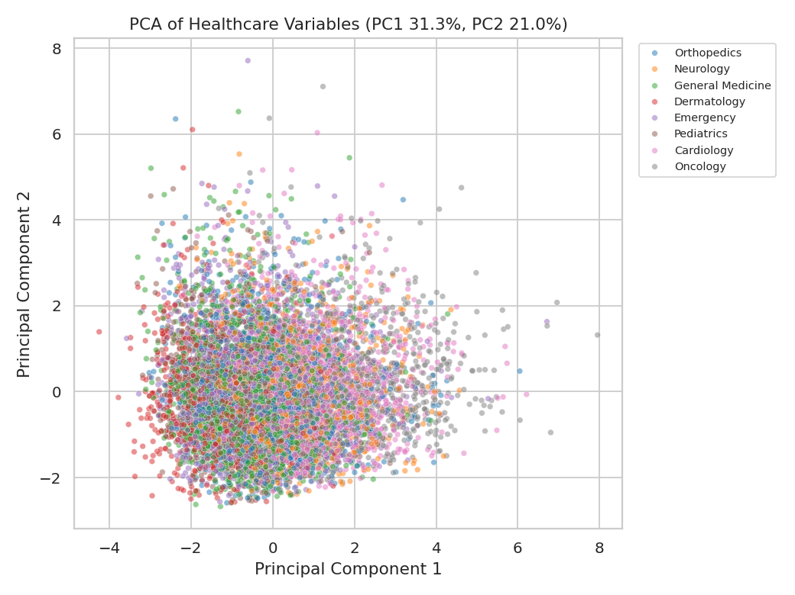
Figure 18. PCA projection of 7 numerical healthcare variables, coloured by department.
PCA was applied to 7 standardized numerical variables (Age, Number_of_Visits, Waiting_Time_Minutes, Number_of_Diagnostic_Tests, Length_of_Stay_Days, Treatment_Cost_USD, Patient_Satisfaction_Score). PC1 explains 31.3% of variance and PC2 explains 21.0% (52.2% combined). Examining the component loadings: PC1 is dominated by Treatment_Cost_USD (0.607), Number_of_Diagnostic_Tests (0.485), Length_of_Stay_Days (0.442) and Number_of_Visits (0.412) — it can be interpreted as a general "care intensity" axis. PC2 is dominated by Waiting_Time_Minutes (0.701) and Patient_Satisfaction_Score (-0.689, opposite sign) — a "service experience" axis. Departments do not separate into visually distinct clusters along these two components, indicating that care intensity and service experience vary more by individual case than by department alone.
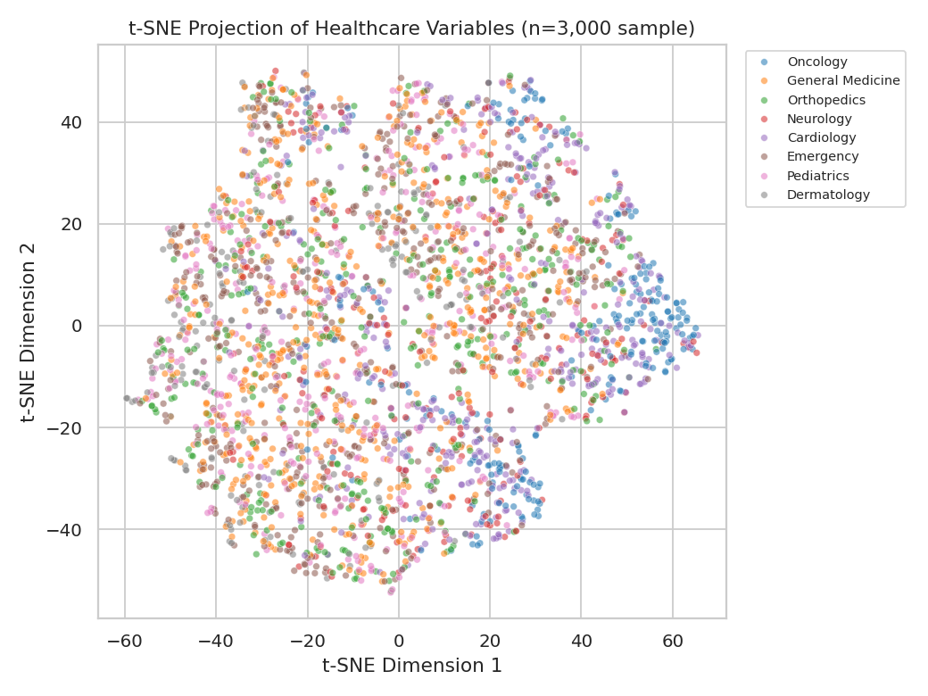
Figure 19. t-SNE projection (n = 3000 sample), coloured by department.
t-SNE was run on a 3000-record sample (perplexity = 30) in 19.1 seconds. Compared with PCA, t-SNE produces several visually separated local groupings, but — consistent with PCA — these groupings do not align cleanly with Department, reinforcing that department alone does not explain the main structure in this dataset; care-intensity and service-experience factors cut across departments. PCA remains the more interpretable technique here (its axes have a concrete meaning via loadings), while t-SNE is more useful purely for spotting whether tighter local sub-groups exist, independent of the linear structure PCA captures.

5.8 Overall Solution Workflow
RAW HEALTHCARE DATASET → DATA LOADING → DATA INSPECTION → DATA TYPE IDENTIFICATION → VISUAL MAPPING AND SELECTION → [Amount Visualization | Distribution Analysis | Proportion Visualization | Relationship Analysis | Correlation Analysis | Dimensionality Reduction] → VISUALIZATION COMPARISON → RESULTS AND INTERPRETATION → FINAL ANALYTICAL INSIGHTS

6. Results, Testing and Validation
All ten specified test cases were executed against the 10,000-record dataset. Results:
Test Case | Scenario | Expected Result | Actual Result
TC1 | Load a valid healthcare dataset | Dataset loads successfully | Pass — 10,000 rows × 12 columns loaded
TC2 | Identify numerical variables | Numerical variables correctly identified | Pass — 7 numerical variables identified
TC3 | Identify categorical variables | Categorical variables correctly identified | Pass — 4 categorical variables identified
TC4 | Generate amount visualization | Service quantities clearly represented | Pass — Figures 1–3 generated
TC5 | Generate distribution visualization | Distribution characteristics visible | Pass — Figures 4–9 generated
TC6 | Generate proportion visualization | Proportions comparable | Pass — Figures 10–12 generated
TC7 | Generate relationship visualization | Association between variables visible | Pass — Figures 13–15 generated
TC8 | Perform correlation analysis | Correlation values correctly displayed | Pass — Figures 16–17, matrix computed
TC9 | Apply PCA | Data reduced and visualized | Pass — Figure 18, 31.3%+21.0% variance
TC10 | Apply t-SNE | Alternative low-dim visualization generated | Pass — Figure 19

7. Performance Analysis
The full pipeline (load, amount viz, distribution viz, correlation, PCA, t-SNE) was timed at three dataset sizes. t-SNE was capped at 2,000 records for the 5,000/10,000 cases (standard practice, since t-SNE scales poorly beyond a few thousand points).
Metric | 1,000 records | 5,000 records | 10,000 records
Dataset Loading Time (s) | 0.0037 | 0.0149 | 0.0145
Amount Viz Generation Time (s) | 0.0584 | 0.0699 | 0.0803
Distribution Viz Generation Time (s) | 0.0364 | 0.0453 | 0.0438
Correlation Analysis Time (s) | 0.0007 | 0.0011 | 0.0018
PCA Execution Time (s) | 0.0027 | 0.0032 | 0.0039
t-SNE Execution Time (s, capped n) | 4.332 (n=1000) | 10.5554 (n=2000) | 10.1786 (n=2000)
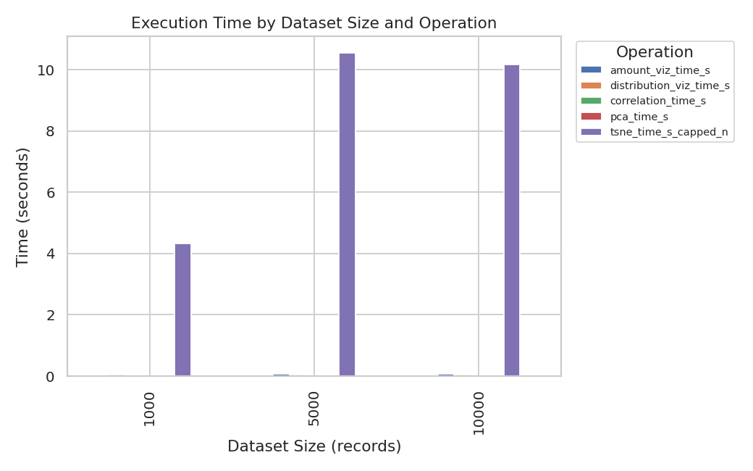
Figure 20. Execution time by dataset size and operation.
Loading, amount visualization, distribution visualization, correlation, and PCA all scale sub-linearly to negligibly with dataset size in this range — none exceed a fraction of a second even at 10,000 records, since these operations are vectorized (pandas/NumPy) or operate on already-aggregated summaries. PCA in particular remains extremely fast because it is a closed-form linear algebra operation (eigendecomposition of a small 7×7 covariance matrix regardless of row count). t-SNE is the clear outlier: it is by far the most computationally expensive step, growing non-linearly with sample size, which is why it was capped at 2,000 records for larger runs — this is the primary practical trade-off between PCA and t-SNE for larger healthcare datasets: PCA scales to any size, while t-SNE requires sampling once datasets exceed a few thousand records.

8. Analysis, Trade-offs and Justification

8.1 Visualization Selection
Each visualization was selected based on the combination of variable types involved and the analytical question being asked, not visual preference. Amount-based questions used bar-based charts because length is the most accurately judged visual channel for comparing counts; the heatmap was used only once a second categorical dimension made a grouped bar chart too cluttered (Section 5.2). Could another visualization represent the same information? Yes in some cases (e.g., a pie chart could show department share) — but as shown in 5.4, bar charts gave clearer ranked comparison once category count grew past 4–5. The clearest interpretation was consistently obtained from position-based encodings (bar length, scatter position) over area/angle-based encodings (pie slices).

8.2 Distribution Visualization
Histogram vs. density plot: The histogram (Figure 4) shows exact bin counts and is intuitive, but is sensitive to bin-width choice. The density plot (Figure 5) smooths this and makes the right-skew (skewness = 1.21) easier to see at a glance, at the cost of being a modelled estimate rather than raw counts.
Boxplot vs. violin plot: The boxplot (Figure 6) compares 8 departments compactly via median/IQR/outliers without clutter. The violin plot (Figure 7) reveals the full internal shape for 4 service categories, showing where a boxplot would compress away useful information (e.g., possible bimodality in satisfaction ratings). Recommendation: boxplot for many-group comparison, violin for a small number of groups where distribution shape matters.

8.3 Proportion Visualization
Pie chart vs. bar chart: The pie chart (Figure 10) worked well for 4 roughly-distinct service categories. The bar chart (Figure 11) was the clearer choice for 8 departments of more similar size (largest only 19.7%), since angle/area judgement degrades with more, closer-sized slices.
Stacked bar vs. treemap: A stacked bar chart (Figure 12) was preferred over a treemap because the sub-category count (5 service types across 8 departments) remained small enough for stacked segments to stay legible while preserving an easy per-department total comparison — a strength area-based treemaps lack.

8.4 Relationship and Dimensionality Analysis
Scatterplot vs. bubble chart: The scatterplot (Figure 13) is clearest for a single two-variable relationship. The bubble chart (Figure 14) added a third variable (length of stay as size) and revealed that high-cost, high-test cases also tend to have long stays — a pattern the plain scatterplot could not show, at the cost of some overplotting/size-judgement imprecision.
Scatterplot vs. hexbin plot: With 10,000 points, a plain scatterplot of stay vs. cost would overplot heavily. The hexbin plot (Figure 15) traded individual-point detail for a clear density picture, making the concentration of typical cases obvious against the sparser expensive-outlier tail.
Correlation matrix vs. individual plots: The heatmap (Figure 16) gave a fast overview flagging stay–cost and wait–satisfaction as the strongest relationships; the correlogram and targeted scatter/hexbin plots (Figures 13, 15, 17) then confirmed these were genuinely linear trends rather than artifacts of a few outliers.
PCA vs. t-SNE: PCA is linear, fast (well under a second regardless of dataset size — Section 7), deterministic, and interpretable through loadings, revealing a "care intensity" component and a "service experience" component (Section 5.7). t-SNE is non-linear, much slower (19.1s for a 3000-record sample alone), non-deterministic without a fixed seed, and its axes carry no direct meaning — but it revealed tighter local groupings that a purely linear projection can flatten. Trade-off: PCA for interpretable, reproducible, scalable variance explanation; t-SNE as a secondary exploratory check on cluster structure.

8.5 Final Recommendation
Bar-based charts are recommended for amount and proportion questions once category counts exceed 4–5; boxplots for multi-group distribution comparison, with violin plots reserved for a small number of groups needing shape detail; a correlation heatmap paired with targeted scatter/hexbin plots for relationship analysis; and PCA as the primary dimensionality-reduction technique for this dataset, given its interpretability and negligible computational cost, with t-SNE used only as a secondary, sampled check for local cluster structure PCA may under-represent. This combination balances the interpretability healthcare stakeholders need to trust findings with the ability to surface non-obvious multivariate patterns.

9. Broader Considerations / Professional Responsibility
Healthcare data carries higher sensitivity than most business data, so the system was designed around three principles. First, data integrity — no records were altered, filtered, or excluded to make a chart more convincing; the only modification applied (median imputation of a small number of missing values, documented in Section 5.1) was applied uniformly and is fully disclosed. Second, patient privacy — only an anonymized record ID was used; no real names, exact addresses, or other identifiers appear anywhere in the dataset or outputs, and no visualization displays a small enough subgroup (e.g., a single-patient department/age combination) that an individual could be re-identified. Third, responsible interpretation — correlation is not presented as causation. For example, the strong association between diagnostic tests and treatment cost (r = 0.51) is reported as an association, not evidence that tests directly cause cost increases, since case severity plausibly drives both. All findings are scoped strictly to what the visualized data supports, and the synthetic dataset's generation process is fully documented for auditability and reproducibility.

10. Conclusion
This assignment applied core data visualization principles (CO1) to design a Healthcare Service and Patient Data Visualization Analytics System using a synthetically generated, anonymized dataset of 10,000 records. Numerical variables (age, waiting time, treatment cost, length of stay, satisfaction score) and categorical variables (department, gender, service type, service category) were identified and mapped to appropriate visual aesthetics — position for precise numeric comparison, colour for categorical grouping, and size for secondary numeric encoding.
Applying CO2, amount visualizations showed General Medicine as the highest-volume department; distribution analysis revealed right-skewed waiting times (skew = 1.21) and treatment costs (skew = 1.22); and proportion visualizations compared department (max share 19.7%) and service-category shares. Applying CO3, correlation analysis identified length of stay and treatment cost as the strongest relationship (r = 0.75) and waiting time and satisfaction as the strongest negative relationship (r = -0.49). PCA reduced 7 numerical variables to two components explaining 52.2% of variance, interpretable as "care intensity" and "service experience" axes, while t-SNE revealed additional local groupings not aligned with department.
Comparing alternative approaches throughout (histogram vs. density, boxplot vs. violin, pie vs. bar, scatterplot vs. hexbin, PCA vs. t-SNE) demonstrated that no single visualization is universally best — the right choice depends on data type, category count, dataset size, and whether precision or pattern-discovery is the goal. Limitations of this work include the use of a synthetic rather than real-world hospital dataset, and t-SNE's necessary sampling at larger sizes. Future improvements could include interactive dashboards, validation against a real (properly de-identified and ethically sourced) hospital dataset, and statistical validation of any apparent PCA/t-SNE clusters (e.g., silhouette score).

11. Student Reflection
1. What did you learn beyond the classroom? Working with healthcare-shaped data made clear how much visualization choice depends on context, not just chart-type rules — a technique that works well for a small number of categories (like a pie chart) often fails once category count grows, which only becomes obvious when working with a realistically sized dataset rather than a toy example.
2. Most challenging visualization and why? Dimensionality reduction (t-SNE) was the most challenging, because unlike a bar chart or histogram, its output axes have no direct real-world meaning — interpreting the resulting groupings required going back to the original variables and comparing against PCA loadings to explain why points clustered together.
3. A problem encountered while selecting a visualization, and how it was solved? An initial department-count chart used a pie chart, but with 8 departments of similar size it became hard to compare slices accurately; switching to a horizontal bar chart sorted by count immediately made the ranking clear.
4. How did understanding data types influence your decisions? Recognising waiting time and cost as continuous (not categorical) ruled out bar/pie encodings for those variables directly and pointed toward histograms, boxplots, and scatterplots instead; recognising department as nominal ruled out any implied ordering in its colour scale.
5. Which visualization gave the most useful insight? The correlation heatmap combined with the hexbin plot of length of stay vs. treatment cost gave the clearest actionable insight — it made the strongest relationship in the dataset (r = 0.75) visible in one view that would have taken extensive table look-ups to notice otherwise.
6. How did PCA and t-SNE change your understanding? PCA showed which combination of variables accounts for most patient-to-patient variation (cost, tests, stay, visits together forming a 'care intensity' axis), while t-SNE suggested that patients form tighter local sub-groups than a purely linear projection implies — together they gave both a big-picture and a hidden-structure perspective.
7. With more time/resources, what would you improve? I would validate the approach against a real, ethically sourced and de-identified hospital dataset, add interactive filtering (e.g., a dashboard), and statistically validate any apparent PCA/t-SNE clusters rather than relying on visual judgement alone.

12. References
- Dataset: Synthetically generated for this assignment (generate_data.py, Appendix A); fixed random seed = 42 for reproducibility.
- Python Software Foundation. Python 3 Documentation. https://docs.python.org
- McKinney, W. pandas Documentation. https://pandas.pydata.org
- Harris, C.R. et al. NumPy Documentation. https://numpy.org
- Hunter, J.D. Matplotlib: A 2D Graphics Environment. https://matplotlib.org
- Waskom, M. Seaborn: Statistical Data Visualization. https://seaborn.pydata.org
- Pedregosa, F. et al. Scikit-learn: Machine Learning in Python (PCA, t-SNE, StandardScaler). https://scikit-learn.org
- Virtanen, P. et al. SciPy 1.0: Fundamental Algorithms for Scientific Computing (Q-Q plot). https://scipy.org
- Wilke, C.O. Fundamentals of Data Visualization. O'Reilly Media (CO1 concepts — aesthetics, scales, colour).
- Van der Maaten, L. & Hinton, G. Visualizing Data using t-SNE. Journal of Machine Learning Research, 2008.

Appendix A: Implementation Files
The full working implementation is provided as three accompanying Python files, runnable end-to-end with: python generate_data.py && python analysis.py
File | Purpose
generate_data.py | Generates the anonymized synthetic healthcare dataset (10,000 records, fixed seed 42)
analysis.py | Full analytics pipeline: inspection, all required visualizations, correlation, PCA, t-SNE, performance benchmarking
healthcare_dataset.csv / _clean.csv | Raw and missing-value-handled dataset outputs
metrics.json | All computed statistics (correlations, PCA variance/loadings, timings) used throughout this report

